

Addressing Opioids in the Workplace
Provided by Wells Insurance

Table of Contents
Introduction 5
What Are Opioids? 6
Opioids vs. Opiates 6
Common Types of Opioids 6
National Epidemic 7
Opioid Abuse Statistics 8
Analysis 8
What Employers Can Do 9
Understanding the Impact 9
Employee Education 9
Explain the Risks 9
Encourage Employees to Speak With a Doctor 10
Promote Your EAP 10
Employee Assistance Programs 11
Benefits of an EAP 11
5 Techniques to Rethink Pain Management 12
Introduce More Benefits for Better Results 14
Mental Health Services 14
Wellness Programs 14
Pain Management Classes 14
Leverage Plan Stakeholders and Their Data 15
Network and Coverage 15
Pain Management Inclusion 15
Employee Usage Numbers 15
Data Evaluation 16
Management Training 16
Identifying Risks 16
Reading the Signs of Substance Abuse 17
Effective Investigative Techniques 18
Other Considerations 18
Reviewing Testing Procedures 19
Know What You Are Looking for 19
Picking a Drug Testing Company 20
Takeaway for Employers 20
Legal Considerations 21
Rules and Regulations to Consider 21
Common Scenarios 21
Conclusion 23
Appendix 24
Effects of Opioid Addiction 25
Opioid Epidemic Fact Sheet 26
5 Techniques to Rethink Pain Management 27
Commonly Used Terms 28
Drug Testing Company Vendor Comparison Worksheet 30
Opioid Alternatives for Pain Management 31
Substance Abuse Incident Report Form 32
Consent to Drug and Alcohol Testing Form 33
EAP Announcement Email for Employees 34
Sample Social Media Communications for Employee Education 35
CDC Campaign Postings 35
Additional Sample Posts 36
Reasonable Suspicion Checklist 37
Opioids in the Workplace: Risk Assessment Scorecard 38
Sample Last Chance Agreement 39
Sample Federal Family and Medical Leave Policy 40
Employee Rights and Responsibilities under FMLA 48

This Benefits Toolkit is not intended to be exhaustive nor should any discussion or opinions be construed as legal advice. Readers should contact legal counsel for legal advice. © 2018 Zywave, Inc. All rights reserved.
Introduction
There are over 42,000 opioid-related deaths in the United States each year, according to the Centers for Disease Control and Prevention (CDC)—a figure that has been rising steadily since the turn of the century. The opioid death rate is now more than five times greater than it was in 1999.
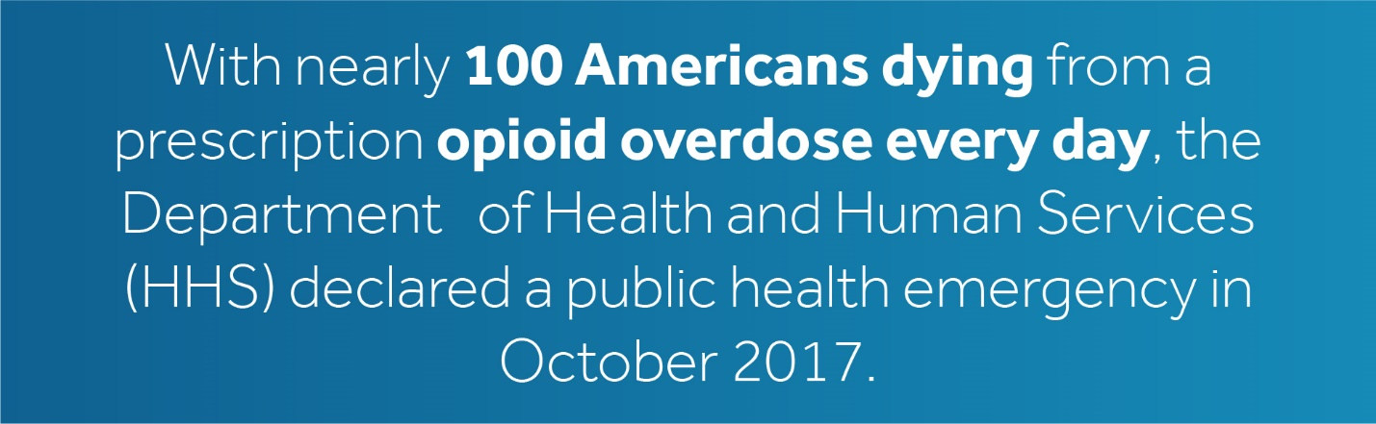

In addition to the skyrocketing opioid-related deaths, there are countless Americans who are still abusing prescription medications. This means employers must figure out how best to address this crisis with employees. That is where Wells Insurance can help.
The purpose of this toolkit is to help employers understand and deal with the opioid epidemic, create a healthier and more productive workforce, and reduce costs. This toolkit is not intended to replace the advice of a medical or legal professional. In many cases, you may need to contact a professional for assistance. However, this information can serve as a starting point for developing a meaningful opioid strategy.

What Are Opioids?
In the most basic terms, the CDC defines opioids as “a class of drugs used to reduce pain.” However, not all opioids are the same. There is a wide range of legal and illegal drugs that are classified as opioids. For example, Vicodin, a legal painkiller commonly prescribed to patients, is an opioid. By comparison, heroin, an illegally manufactured drug that has no medical use, is also an opioid. Both are killing thousands each year.

Opioids vs. Opiates
These terms are used interchangeably by many who report on the opioid crisis. While this may be fine for a basic understanding, knowing the difference between opioids and opiates could matter to your organization’s plan administrator.
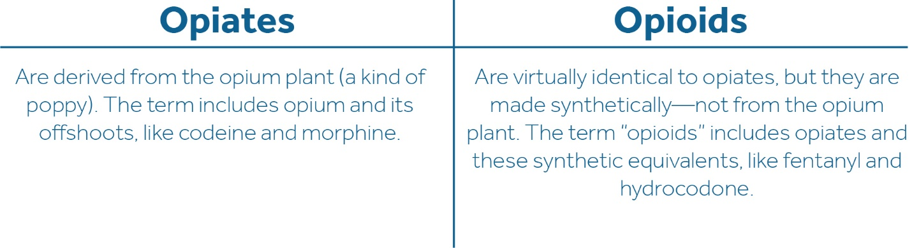

This toolkit uses the term “opioid” exclusively to include both categories of drugs.

Common Types of Opioids
It should be clear by now that many drugs are considered opioids. Here are the names of some commonly abused opioids, with their brand names listed for recognition. These include prescription medications and illegal offshoots.
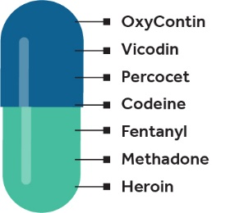

National Epidemic
Opioid abuse is a national epidemic. Drug overdoses are one of the leading causes of death for Americans under the age of 50, according to data from the National Center for Health Statistics. With the popularity of synthetic opioids surging, experts predict the death toll will only increase.
Unlike other drug epidemics, the reach of opioids is unique. This crisis affects all people in all economic classes, but in different ways. People who can afford prescription drugs are just as susceptible to an overdose as those who cannot afford them because of the unprecedented availability of cheap substitutes. This can make it extremely difficult to create a meaningful opioid strategy.
Widespread availability illuminates an ironic problem for this epidemic: the solution is not withholding opioids altogether. The United States traditionally takes a hardline approach to drugs. It cracks down on manufacturing and distribution networks, outlaws substances and attempts to eliminate the product from the market. Unfortunately, this epidemic is especially difficult to control as many of these drugs are legally prescribed by doctors.
Pharmaceutical companies created opioids and aggressively pushed these medications to doctors during the 1990s. The market soon became flooded and the number of patients being prescribed opioids rose sharply. Over the years, prescription pill addictions transformed and many began using heroin and fentanyl. Now, the country must figure out how to contend with a saturated market, new synthetic drugs and an unrelenting overdose rate.
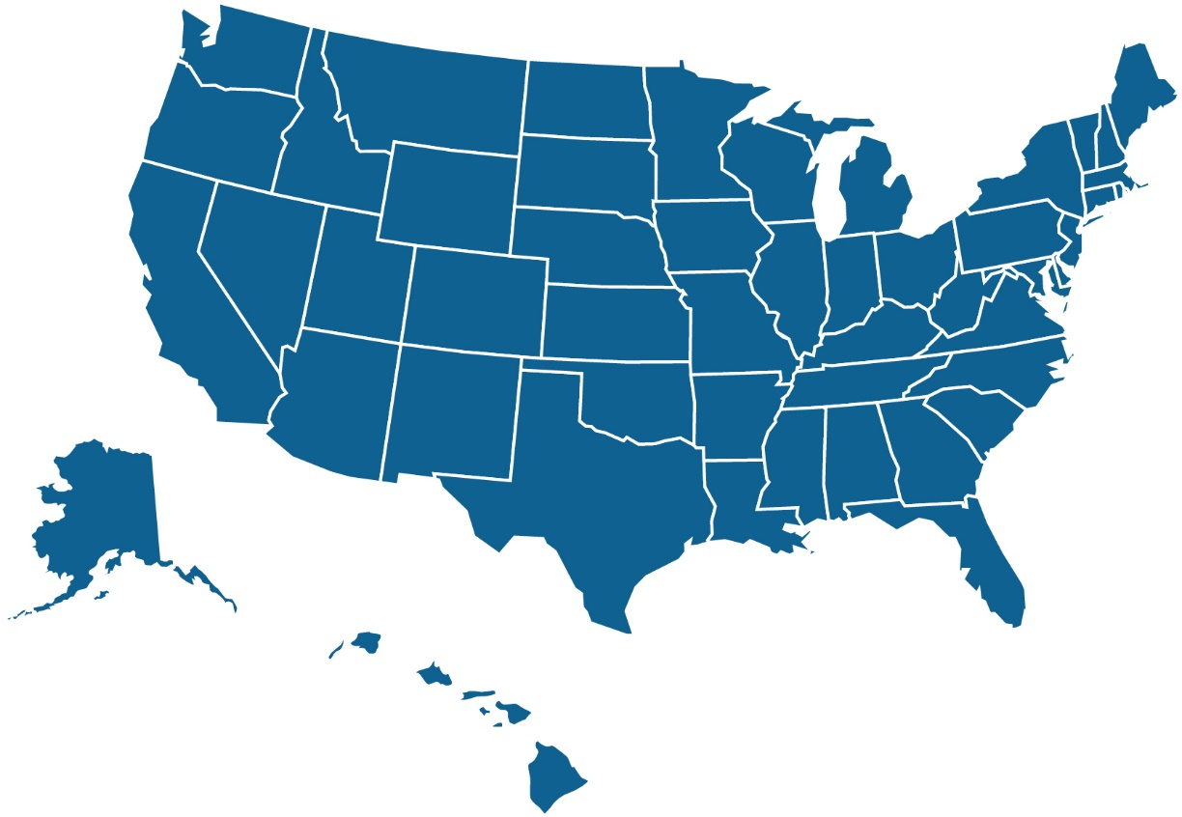

Opioid Abuse Statistics
These graphs illustrate the steep increase in opioid abuse between 2015 and 2016 alone. This information is based on provisional data from the National Center for Health Statistics, which may not reflect the actual figures due to underreporting at the time.
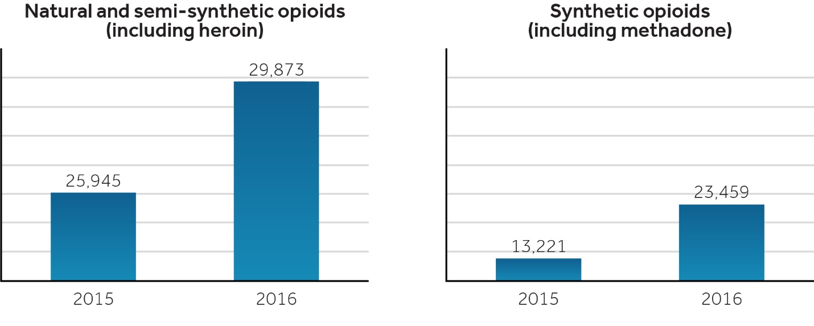

Analysis
The number of opioid prescriptions jumped from 76 million in 1991 to 207 million in 2013. Now, two decades later, America struggles to separate abuse from legitimate use.
Simply outlawing prescription opioids is not the answer. Many still serve important roles, like managing acute pain and anesthetizing patients. However, both legitimate and illegitimate use of opioids can lead to tolerance and require higher dosages to get the same effect. This can lead to addiction, and, in many cases, it can lead to an overdose.
Synthetic opioids, like fentanyl, are much more potent than more commonly prescribed opioids. When users switch to these more concentrated forms, they are at extreme risk of overdosing. Users see a more potent alternative on the market, so they jump on the supposed deal. Unfortunately, many do not realize they must take smaller dosages of the new drug and end up overdosing.
These tragic details cover only a small portion of the opioid crisis. There are still thousands trapped in the cycle between addiction and relapse. With the proper resources and planning, you can do your part and help your employees who are in need. Do not wait for any more overdoses before taking action.

What Employers Can Do
The opioid crisis is not going away. Estimates show this epidemic costs the U.S. economy over $95 billion annually, with employers paying $18 billion of that themselves. And, these figures are only expected to rise. Employers need to do everything possible to combat the impact opioids have in the workplace.
There is no silver bullet for this crisis. However, exploring new initiatives can help you develop your own strategy to best suit the needs of your employees. This section provides examples that may help you.

Understanding the Impact
Employers across the country are working to curb the misuse of prescription opioids. With more employees falling victim to addiction, employers are seeing lower productivity, higher health care costs and fewer qualified job applicants.
When so much of the workforce is at risk of opioid abuse, that can put a strain on benefit programs—especially health care costs. Overprescribing creates ample room for abuse, which can result in employers paying more for their drug plan than they need to be.
It can be hard to identify illegitimate use, especially with prescribed medications. Employers may need to try more unique approaches to curb opioid abuse. Addressing the problem with employees directly can be a good place to start.

Employee Education
Opioid abuse is not happening in a vacuum. Even if employees themselves are not using opioids, their lives may be affected by loved ones who are. This can indirectly affect their job performance and contribute to the overall crisis.
Employers should do their best to provide employees with educational materials to help them understand and take action against the opioid crisis. Lasting reform can only happen if individuals take charge of their situation. Educating employees is the first step.


Consider the following suggestions when developing your own communication campaign:

Explain the Risks
Reminding people about addiction’s tragic side effects could help motivate them to abstain from or seek treatment. Directly facing the consequences of your actions can be powerful, especially when paired with other resources. Try putting up posters or sending information directly to employees that calls attention to the dangers of opioid misuse.

Encourage Employees to Speak With a Doctor
Sometimes employees do not think to speak to their doctors about opioid abuse. This could be because employees are worried about losing their prescriptions, or perhaps they do not know how their doctor could help. Regardless, a doctor is more qualified than your organization’s HR department to help with medical issues stemming from opioids.
Educate employees on the importance of speaking openly with their doctors. If they are worried about losing a prescription, explain that there are other effective ways to treat chronic pain. Most importantly, reassure employees that their doctors are there to help, not get them in trouble for misusing medication.

Promote Your EAP
Employee assistance programs (EAPs) can be extremely beneficial for your workforce. Traditionally, EAPs help with personal issues, like smoking cessation or stress management. However, they can also help with opioid usage.
Like any other EAP, a program geared specifically toward opioids can help employees deal with this debilitating addiction and put energy back into their job. Read more about EAPs in the following section.

Employee Assistance Programs
Because substance abuse and mental health issues can impact the workplace so significantly, many companies choose to offer EAPs. However, an EAP is only useful if it is tailored to your employees’ needs. In this case, employees need resources to fight their opioid addictions.
An EAP supplies professionals who provide counseling to employees and their families in a safe and private atmosphere. Generally, all the information disclosed will remain confidential, and no disclosure to employers will be made without written permission. Using an EAP will not jeopardize an employee’s job or chance for promotion, which are two repercussions many drug users fear. These factors lower barriers and can encourage more people to seek help.
The EAP makes a limited number of counseling sessions available to employees at no cost. Should an employee and his or her counselor decide that a referral to an outside provider is necessary, those costs will then be the employee’s responsibility.
Consult your EAP vendor to determine what the payment structure looks like so you can advise employees on best usage practices.

Benefits of an EAP
An EAP not only helps employees, it helps the entire business. When employees are in good mental and physical health, the whole organization benefits.
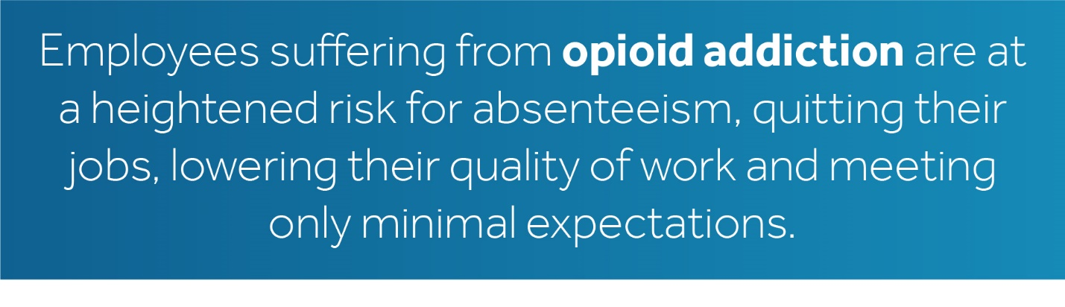

Offering an EAP can put employees in touch with experts who can help start their treatment.
Opioid addiction should be treated like a chronic illness. Simply providing one treatment option will not help create lasting change. It takes time, energy and ongoing treatment to help reverse opioid addiction.
Speak with your EAP vendor to discuss adaptions that can better meet the needs of your workforce.

5 Techniques to Rethink Pain Management
NOTE: Pain management is a complicated issue that can affect anyone, regardless of background. Use this information to familiarize yourself with pain management options. A printable version for your employees is available in the appendix.
There are many levels and different types of pain, making stand-alone treatment near impossible. Oftentimes, you may receive a prescription for your discomfort and nothing else. You are expected to treat your pain with the pills alone.
However, taking a pill is not always the best solution for managing pain, and that treatment method can lead to misuse and addiction. When abused, prescription medication usage can spiral into addiction and bring about disastrous consequences. If you are suffering from chronic pain and worry about the dangers of addiction, speak with your doctor about these alternatives:

This method is commonly incorporated into treatment strategies because of its proven benefits. Physical therapists specialize in getting to the root cause of pain, instead of focusing on its symptoms. Additionally, having someone direct your treatment can be more beneficial than using pills alone.

Meditation is gaining popularity among those who want a more holistic approach for managing their pain. The method is focused on treating your body through your mind, arguing that one is no more important than the other. While exact practices differ, meditation tends to focus on activating and bolstering the areas of the brain that deal with pain through a variety of mental exercises.

Acupuncture is an ancient practice that dates back thousands of years. The basic treatment involves pressing tiny needles with various degrees of pressure in specific points on the body. This is said to help control your body’s energy flow, which is believed to treat pain and other conditions.

Chronic pain can linger for years without any relief, since it usually involves many underlying factors. For this reason, sufferers often avoid doing tasks that can cause pain. However, this can further the problem and make it even harder to do those tasks later on. Doing routine stretches and minor exercises, like walking, can help manage chronic pain and make it easier to move around as you age.

While its name may invite skepticism, hypnotherapy is actually an accepted method for managing pain. Methods vary, but hypnosis usually involves enhancing concentration and increasing responsiveness. This focused state is reported to help people isolate and, eventually, decrease the sensitivity of the pain.

Introduce More Benefits for Better Results
EAPs and employee communication campaigns can be great for encouraging employees to get help for their addictions. Integrating these methods with other benefits options can create a more comprehensive opioid combat strategy. Here are some additional benefits you can offer to bolster your efforts:

Mental Health Services
Many health plans include access to some mental health services, but there may be more you can offer. Services like behavioral treatment, mental health inpatient services and substance abuse programs can strengthen your health plan and add greater value for employees. Speak with Wells Insurance about tailoring your health plan to incorporate these and other meaningful services.

Wellness Programs
Sometimes employees need an extra push to get started living a healthier lifestyle. Wellness programs could help do just that. Examples include subsidized gym memberships, weight-loss programs with prizes for hitting milestones, coupons for local health food stores, free health screenings and discounted personal training.
Opioid addiction can take sufferers down a dark path. These wellness programs—and their perks—can help encourage healthy behaviors and provide guidance for those in need. Paired with other treatment programs, wellness programs can help ensure those coping with addiction have a healthy mind and body.

Pain Management Classes
There are a number of pain management classes available for employees. Some are specifically created to combat the overreliance on prescription painkillers. These classes help educate opioid sufferers about sustainable pain management. Typically, programs integrate with multiple health professionals, like doctors, pharmacists, nurses and therapists. The goal is to teach patients about their risk of addiction if they are taking high doses of opioids and to inform them about alternative pain management techniques. This integration and ample resource allocation can create lasting change for those in need.

Leverage Plan Stakeholders and Their Data
Employers are not alone in their battle against opioid abuse, as many other parties deal with this growing workplace crisis. Some of the most helpful individuals are your plan administrator, carrier and pharmacy benefit manager (PBM). These professionals are your resource for getting to the root of the opioid problem within your organization. Since they manage your pharmacy benefits, PBMs, plan administrators and their carrier affiliates have control over virtually every aspect of your employees’ prescriptions.
Start a conversation with these professionals about tailoring your pharmacy benefits to contend with the realities of workplace opioid addiction. Focus on the following suggested topics:

Network and Coverage
Adjusting your pharmaceutical network can help limit the places where employees are able to fill their prescriptions. For instance, some pharmacies set limits on opioid prescriptions during a certain time frame, so narrowing the network can help control opioid access. Additionally, a smaller network helps prevent employees from “double-dipping” and getting multiple prescriptions from different doctors. You can even limit the quantity of pills employees get when filling an initial prescription, which can also reduce the risk of overprescribing.

Pain Management Inclusion
As the previous sections emphasize, there are many alternatives to managing pain besides opioids. Physical therapy and acupuncture are examples of drug-free solutions, but there are also non-opioid prescriptions that can help. Covering these and other options under your pharmacy benefits can reduce employees’ risks of forming addictions. Additionally, some employees may not want to use opioids, but feel constrained by what their insurance will cover. Including alternative pain management options will allow employees to choose the best solutions for their lifestyles.

Employee Usage Numbers
Understanding the scope of the opioid problem in your workplace is the first step to applying worthwhile changes to your pharmacy benefits. Your PBM can provide data on how many employees are using opioids and the frequency with which they fill prescriptions. Knowing these figures can help you determine where you need to make adjustments. For instance, if employees are filling their prescriptions every week or frequently visiting multiple doctors, you can focus on narrowing your coverage network.
Your plan’s professionals can help you make sense of the data and implement effective changes. Self-insured plans are especially well-equipped for getting data about what is affecting employees. Keep in mind the data must be refined so it does not identify specific employees, to comply with the Health Insurance Portability and Accountability Act (HIPAA). This is something your plan’s professionals can help with.

Data Evaluation
You have access to large amounts of employee and plan data. Speak with Wells Insurance, plan administrators or your PBM to find out who has your data. It can be overwhelming if you are unsure what to look for among the rows of pharmaceutical usage figures. A better approach may be to start with questions that you need answered and letting plan professionals identify applicable data sets.
For instance, you may want to know if opioids are being used more heavily by employees than in years past and if dosages have followed the same trend. Your plan professionals can help analyze the data and paint a detailed picture. As always, be sure to comply with all HIPAA restrictions. Consult with your plan professionals for more information.

Management Training
Managers are an organization’s first line of defense for mitigating the effects of opioids in the workplace. These are the individuals who help train, evaluate and manage employees, which allows them to view the opioid impact on a personal level. Since managers interact individually with staff on a regular basis, they can more easily spot patterns and identify employees exhibiting signs of substance abuse. Training managers to recognize these signs is extremely important for getting ahead of opioid addiction in your workplace.

Identifying Risks
Substance abuse is not always easy to spot, especially when it comes to opioids. Simply relying on common signs will not be sufficient for manager training. Managers should be taught to identify risks beyond the common signals of substance abuse, like an obvious odor of alcohol or bloodshot eyes, as these do not typically apply to opioid abusers. Sometimes employees go to great lengths to conceal their addictions from their employers. Managers must be vigilant to spot individuals who may be flying under the radar.
Other potential identifiers of opioid abuse include employees facing sudden financial problems and exhibiting uncharacteristic mood swings. Managers should be familiar with these and other problem signals, and they should know how to proceed when they are identified. Consult your internal drug policy to ensure it clearly explains reporting procedures and includes steps for tactfully handling reasonable suspicion.
Keep in mind substance abuse signals do not equal verified abuse. Be sure your drug policy outlines verification steps for managers and discourages baseless profiling.

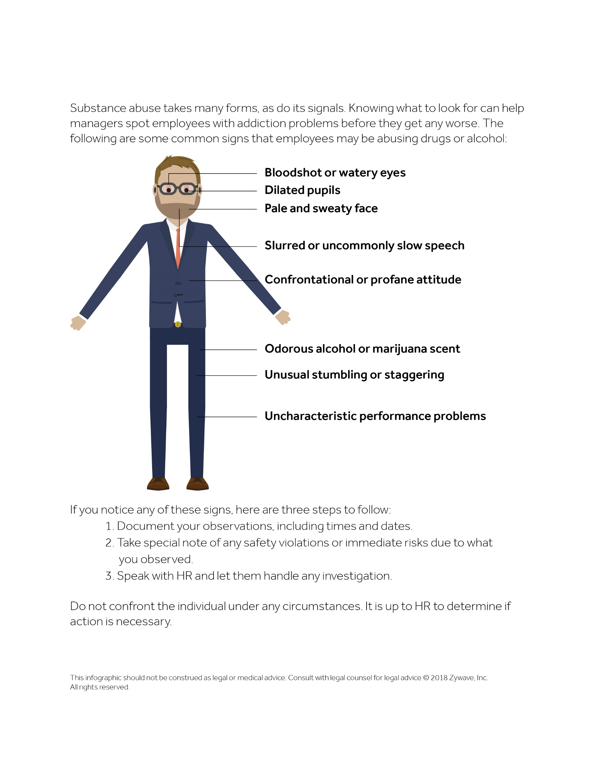
Reading the Signs of Substance Abuse

Effective Investigative Techniques
Properly investigating claims made against employees requires involvement from a number of stakeholders, most importantly HR. Effectively dealing with alleged substance abusers can be complicated, and incorrectly identifying substance abuse can create tremendous strain on employee relationships.
HR should know the correct way to approach employees about suspected substance abuse. Below are some techniques for addressing the topic. Visit the appendix for a more thorough checklist regarding reasonable suspicion.
- Consult your drug policy and follow all the appropriate steps before speaking with the employee.
- Speak with other stakeholders within your organization about the situation.
- Confidentially approach the employee in a safe environment with appropriate stakeholders present.
- Allow the EAP professionals to diagnosis and make any treatment referrals.
- Monitor the employee and continue to track his or her performance.
- Follow up with the employee periodically (and confidentially) to see if he or she needs additional help or resources to stay on course with treatment.

Other Considerations
Training managers to spot and deal with substance abusers should be a top priority for any organization. While training programs vary, here are other aspects to keep in mind:
- Require managers to learn proper communication techniques for speaking with employees about substance abuse.
- Set up mandatory training on potential HIPAA violations that may help managers during delicate conversations.
- Consider the Federal Transit Administration’s training about acting on reasonable suspicion. Similar videos may benefit your staff.

Reviewing Testing Procedures
Alcohol and drug testing is more important to some industries than it is to others. However, if a situation arises where a test is needed, you should know if it is being done properly. That is why reviewing your internal substance testing policy is so important. Here are some additional points to consider when looking over your policy.

Know What You Are Looking for
Your organization can choose from a wide variety of drug testing options, which can be a problem if you are unsure what their differences are. Some only test for specific drugs, others test for high concentrations and the quality of results vary by type. Moreover, only certain tests can detect opioids and their synthetic derivatives, which makes selecting the right testing method critical.
With this in mind, take note of your organization’s testing methods to ensure you are looking for the right substances. The following are a few testing methods and their explanations:
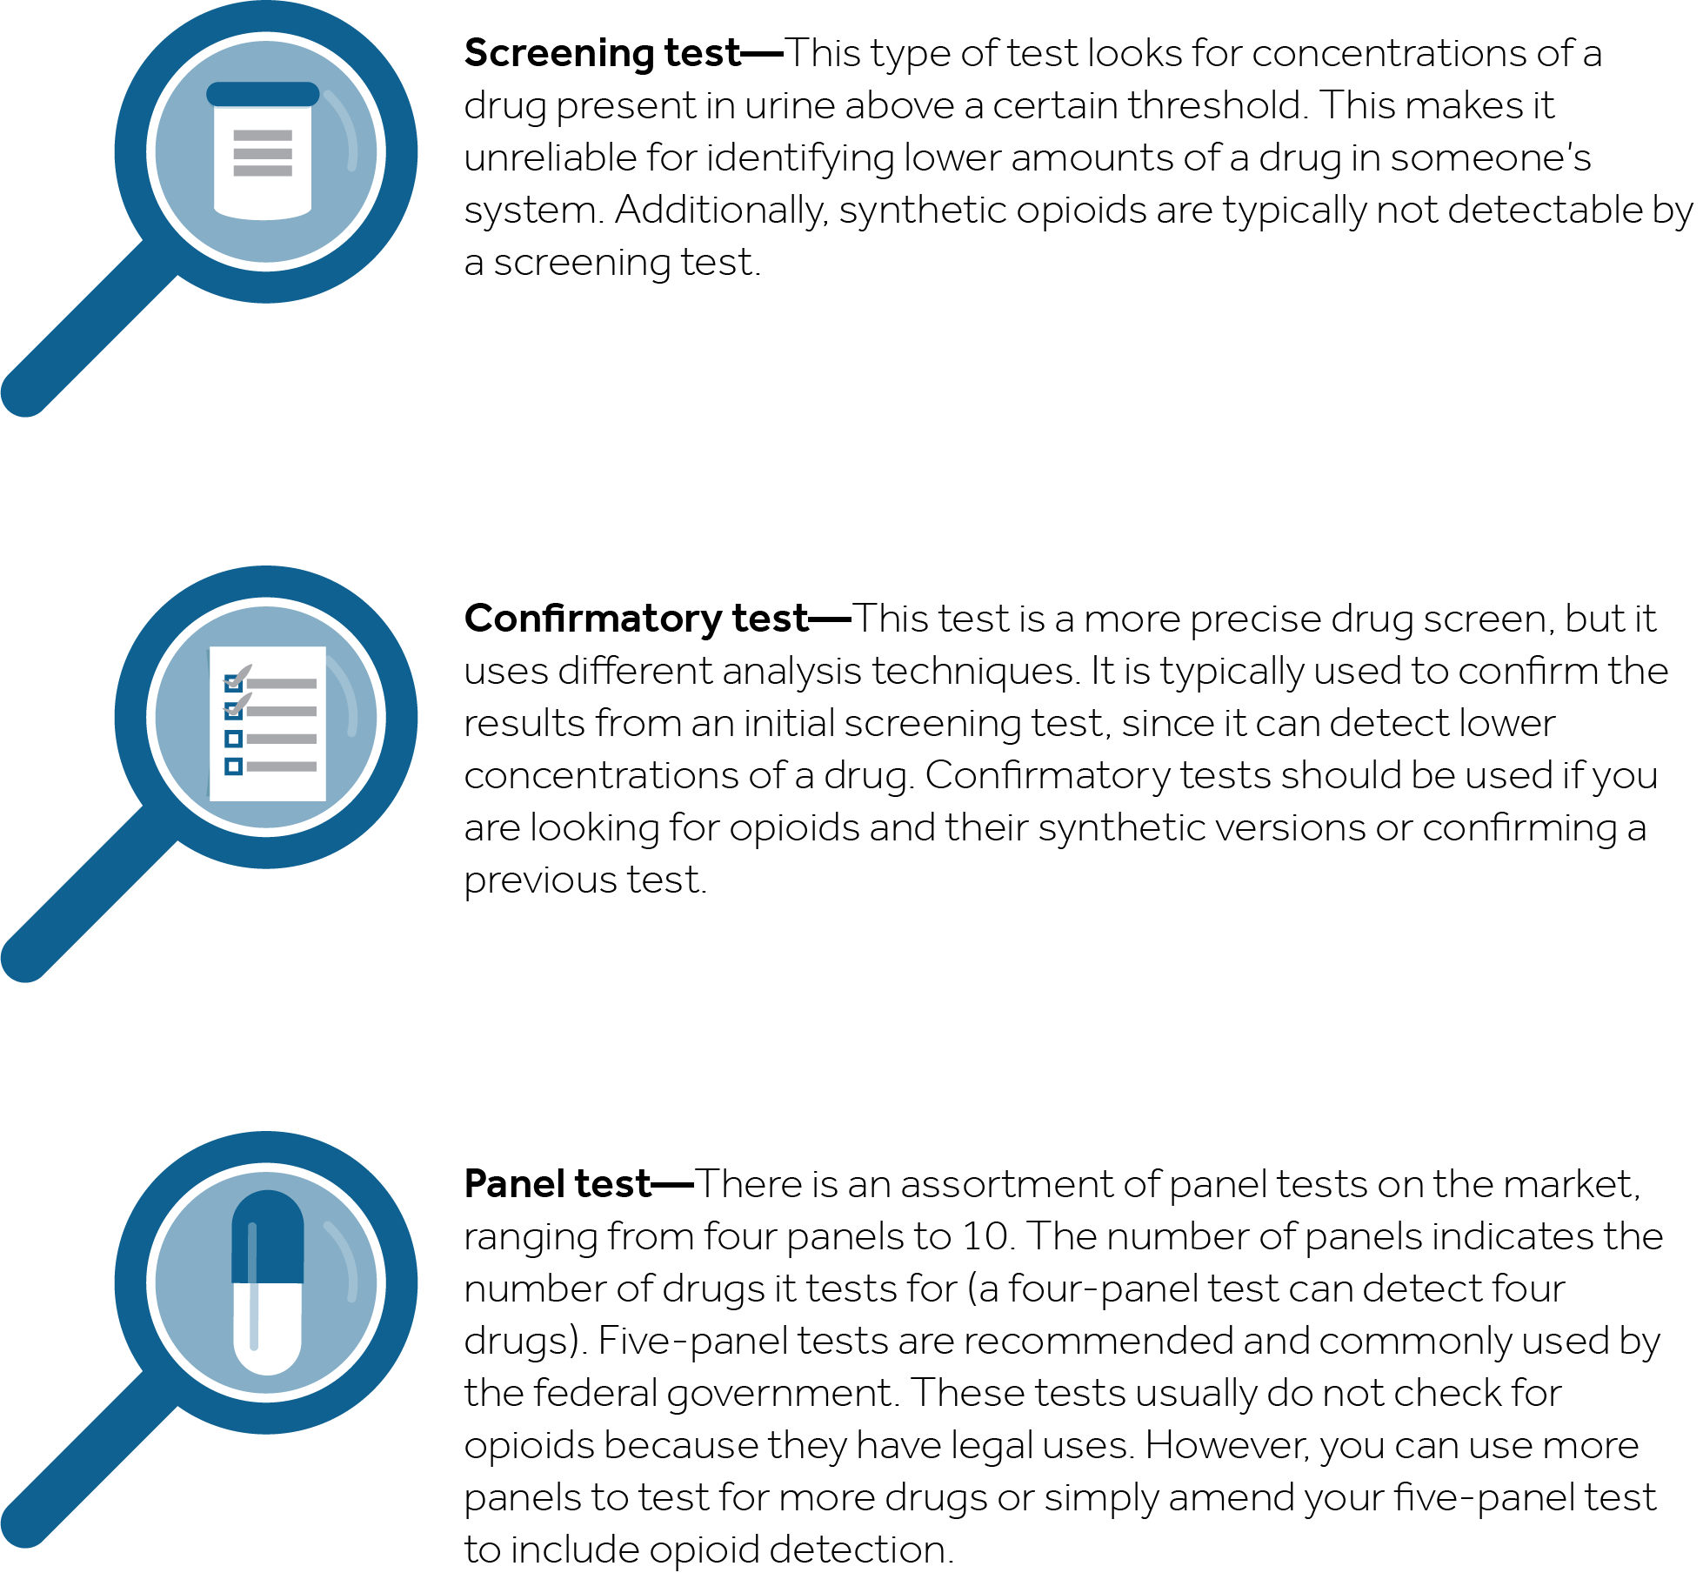

Picking a Drug Testing Company
Choosing the best drug testing company for your organization can be just as important as the testing methods you use. Testing companies differ in a number of ways, so knowing which qualities to look for is crucial. Keep in mind that you are trusting these companies to deliver accurate testing results, which is a huge responsibility given the potential consequences for employees.
Here are some aspects to look for when reviewing potential companies to partner with. This list is also featured as a comparison worksheet in the appendix for use when looking at potential vendors.

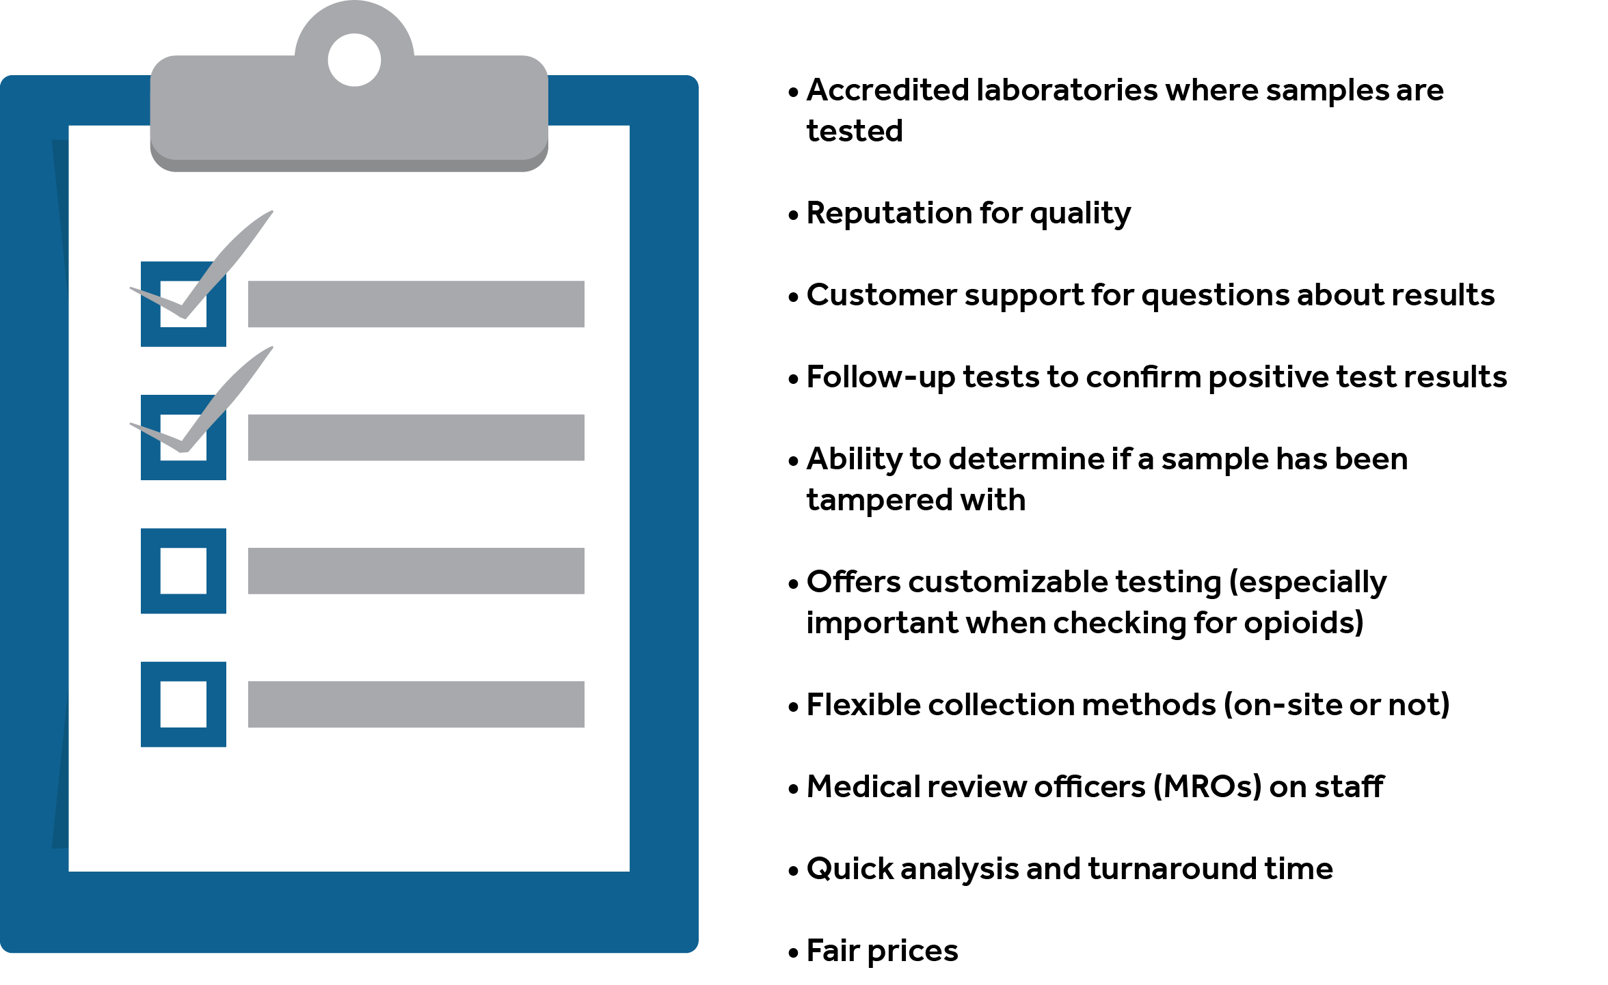

Takeaway for Employers
Determining whether to test for illicit substances is a significant decision that all employers must make. While its importance varies by industry, understanding how to gauge the quality of the company you partner with—and its testing methods—will benefit you greatly if a situation warrants a test. Knowing the factors related to effective drug testing can help you tailor your internal policy and more accurately target the problem drugs in your workplace.
Have an MRO review your drug policy to ensure it outlines key provisions, like appropriate testing thresholds, specific situations that warrant a test (immediately following an accident, for instance) and when to use a confirmatory test. Speak with an MRO, legal counsel or plan administrator for any guidance when reviewing your policy.

Legal Considerations
As with every other section in this toolkit, you must consider the legal pitfalls surrounding the proper ways to deal with employees suspected of abusing prescription drugs. Below are some aspects to keep in mind when reviewing your internal guidelines and procedures.

Rules and Regulations to Consider
The following are examples of the laws you should be aware of when navigating employee prescription drug usage. For an exhaustive list of legal requirements and issues that may relate to your situation, you will need to speak with legal counsel.
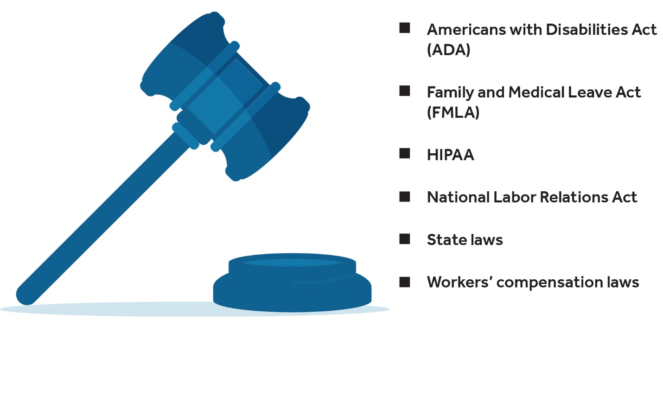

Common Scenarios
Here are a few scenarios to consider when examining your organization’s protocols:
- FMLA guarantees certain employees unpaid leave each year. Employees can use FMLA for treatment for a serious health condition, which includes a physical or mental condition that involves inpatient care or continuing treatment by a health care provider. However, FMLA leave is not available just because someone is impaired by opioids. Seek legal counsel if you have more questions.
- Terminating employees who are on job-protected leave for an illness or disability can be risky. Employers may want to consider implementing a last-chance agreement in these situations.
- Under the ADA, individuals who are addicted to drugs, but who are no longer using drugs illegally and are receiving treatment for drug addiction or who have been rehabilitated successfully, are protected by the ADA from discrimination on the basis of past drug addiction. If the employee continues to use illegal drugs, he or she is not protected by the ADA. The ADA requires reasonable accommodation for individuals entitled to protections under the ADA. For example, leave may be required for individuals who are no longer using illegal drugs and are undergoing treatment.
- Employers can hold employees to the performance standards that apply to their jobs. Employers can also prohibit the use of drugs in the workplace and prohibit employees from being under the influence of drugs in the workplace.

Conclusion
Opioid abuse kills over 90 people each day and costs employers alone around $18 billion in lost productivity, absenteeism and other expenses paid dealing with addicted employees, according to the Financial Times. Ironically, since the majority of Americans are covered by employer-sponsored health plans, employers are paying for the same drugs that are ravaging their businesses and employees.
Employers must take an active role in curbing opioid abuse in the workplace. Companies that do not are risking lawsuits and a litany of HR headaches. By understanding the scope of the epidemic, acknowledging the risks your workforce faces and re-evaluating internal policies, your organization can more effectively manage employees struggling with opioid addiction. Speak with Wells Insurance if you have any questions about where to begin on your journey to a safe and productive work environment. Together we can help improve the health of your business, your employees and your bottom line.
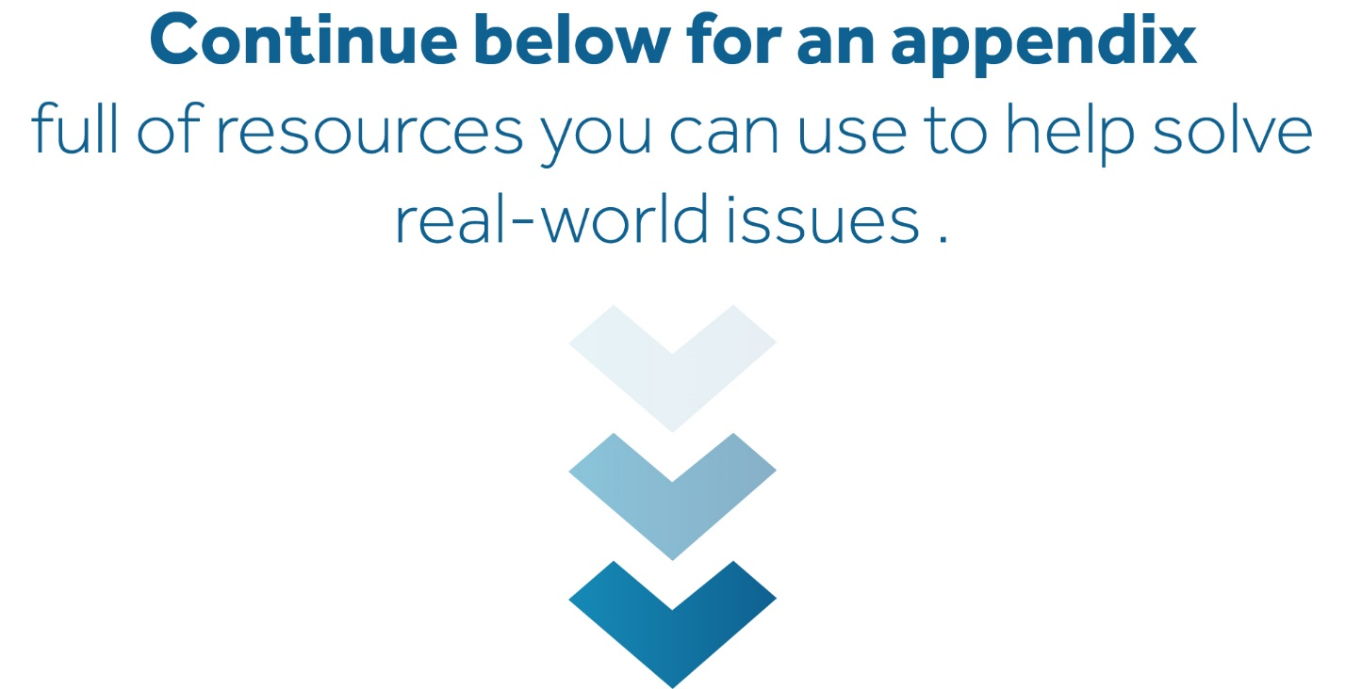

Appendix
The opioid crisis grows daily and affects every corner of American society. Employers must do everything they can to help reduce this alarming trend. This appendix features many useful resources to help combat opioid abuse in the workplace, including infographics, employee communications and sample internal policies.
Speak with Wells Insurance if you have any questions about the valuable resources offered in this appendix. Please note some of the information may need to be tailored to best suit your organization.

Printing Help
There are many printable resources in this appendix. Please follow the instructions below if you need help printing individual pages.
- Choose the “Print” option from the “File” menu.
- Under the “Settings” option, click on the arrow next to “Print All Pages” to access the drop-down menu. Select “Custom Print” and enter the page number range you would like to print, or enter the page number range you would like to print in the “Pages” box.
- Click “Print.” For more information, please visit the Microsoft Word printing support page.

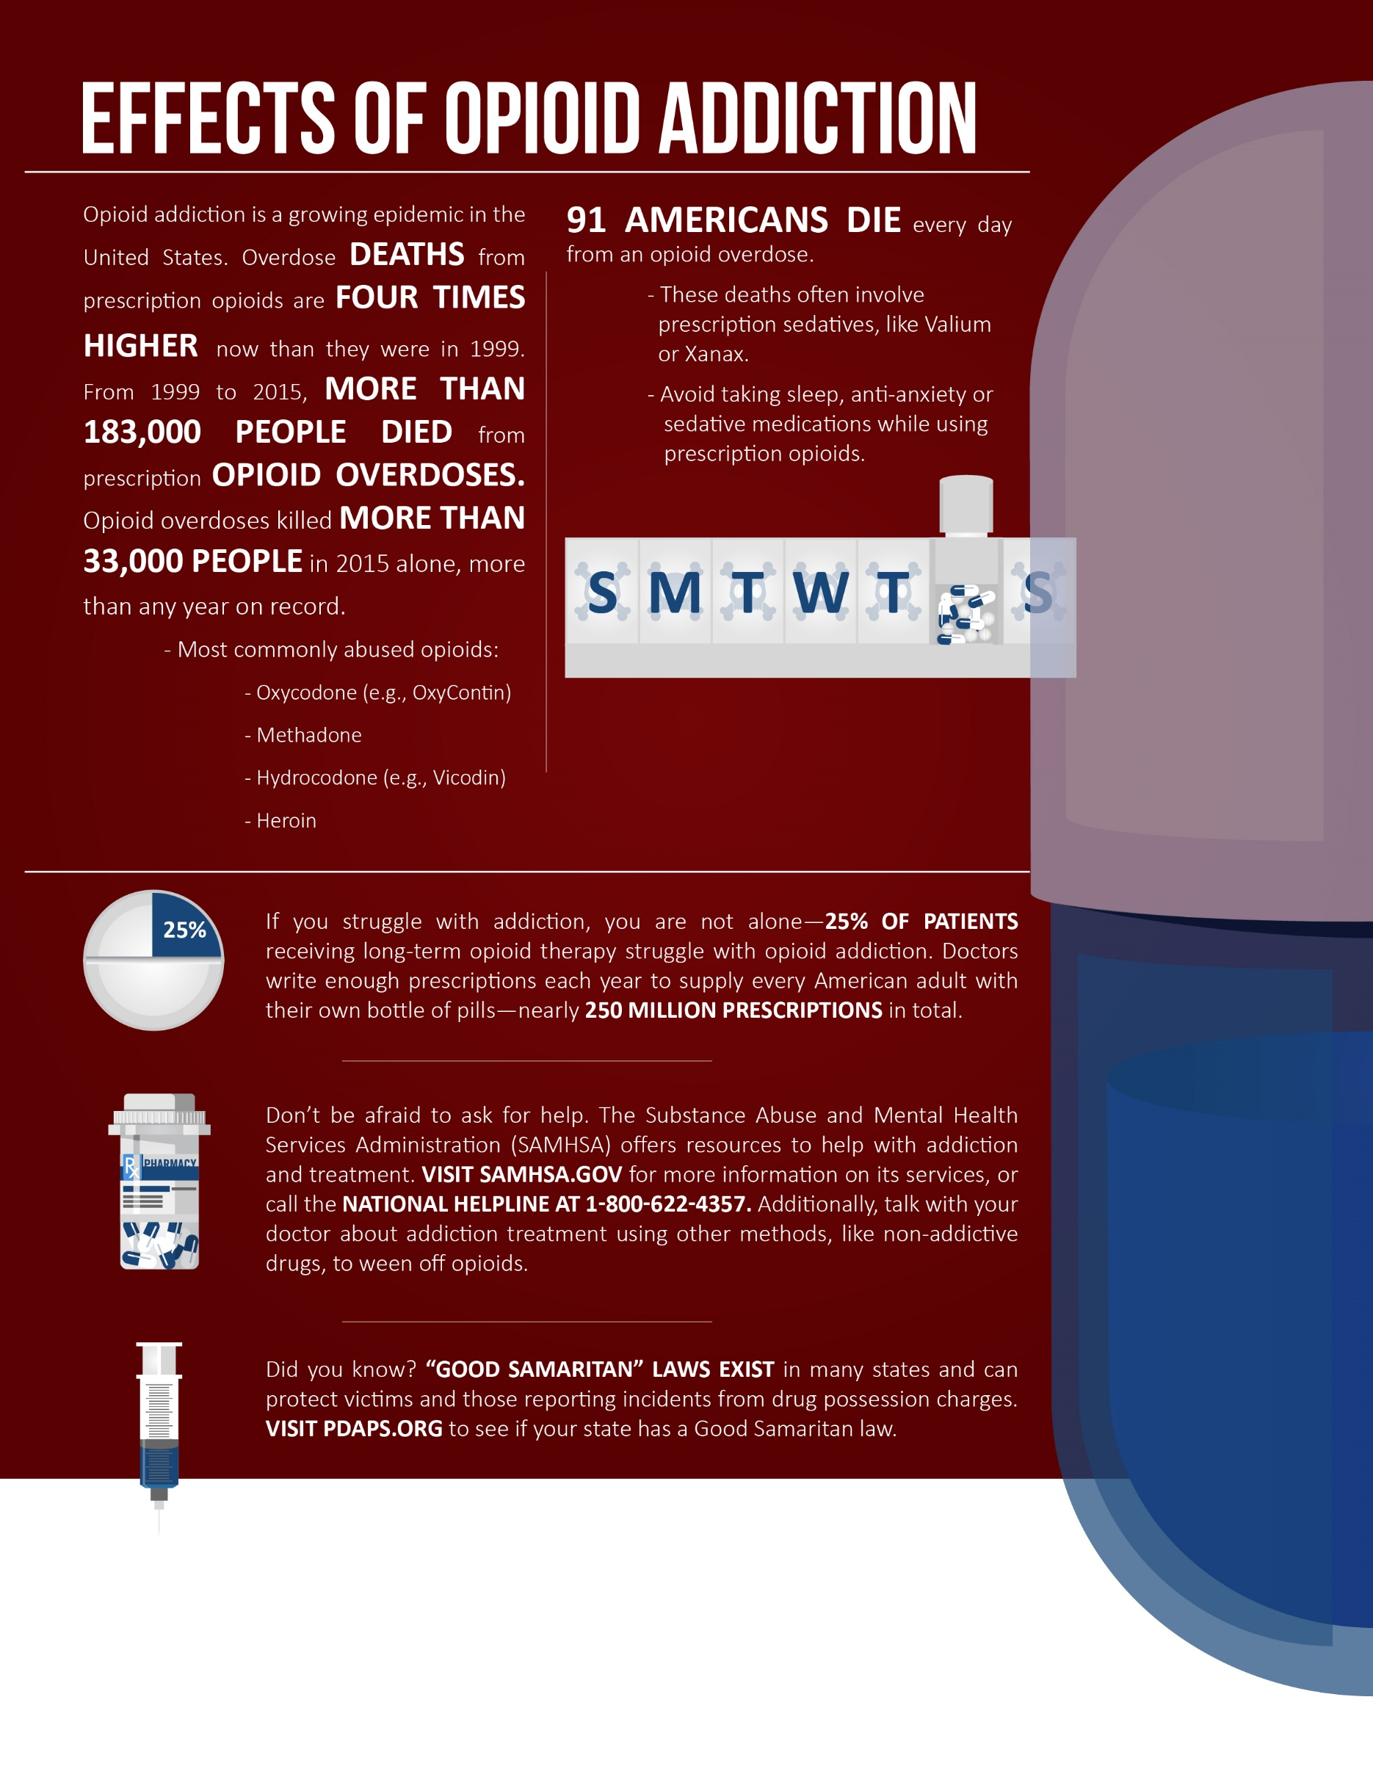
Effects of Opioid Addiction
Source: Centers for Disease Control and Prevention
The information contained in this infographic is not intended as legal or medical advice. Please consult a professional for more information. © 2017 Zywave, Inc. All rights reserved.

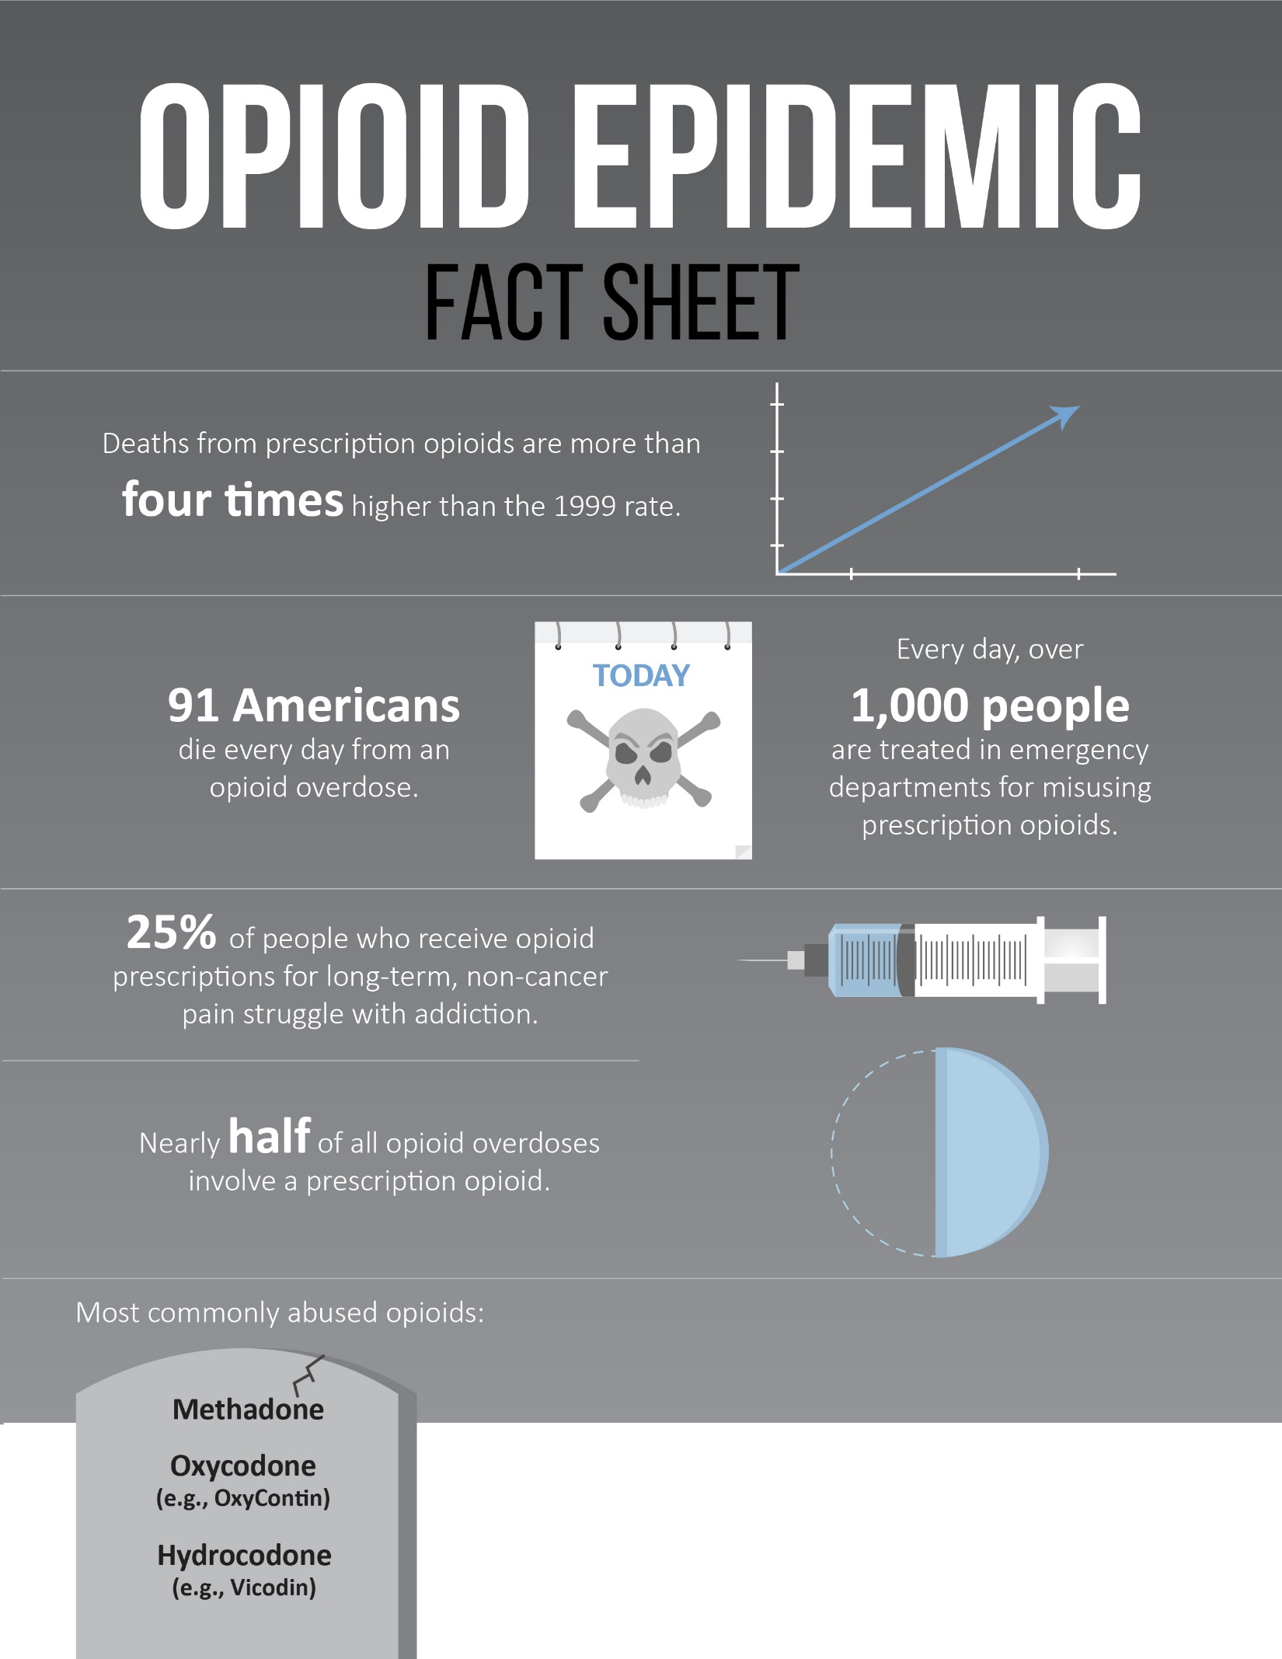
Opioid Epidemic Fact Sheet
The information contained in this infographic is not intended as legal or medical advice. Please consult a professional for more information. © 2017 Zywave, Inc. All rights reserved.

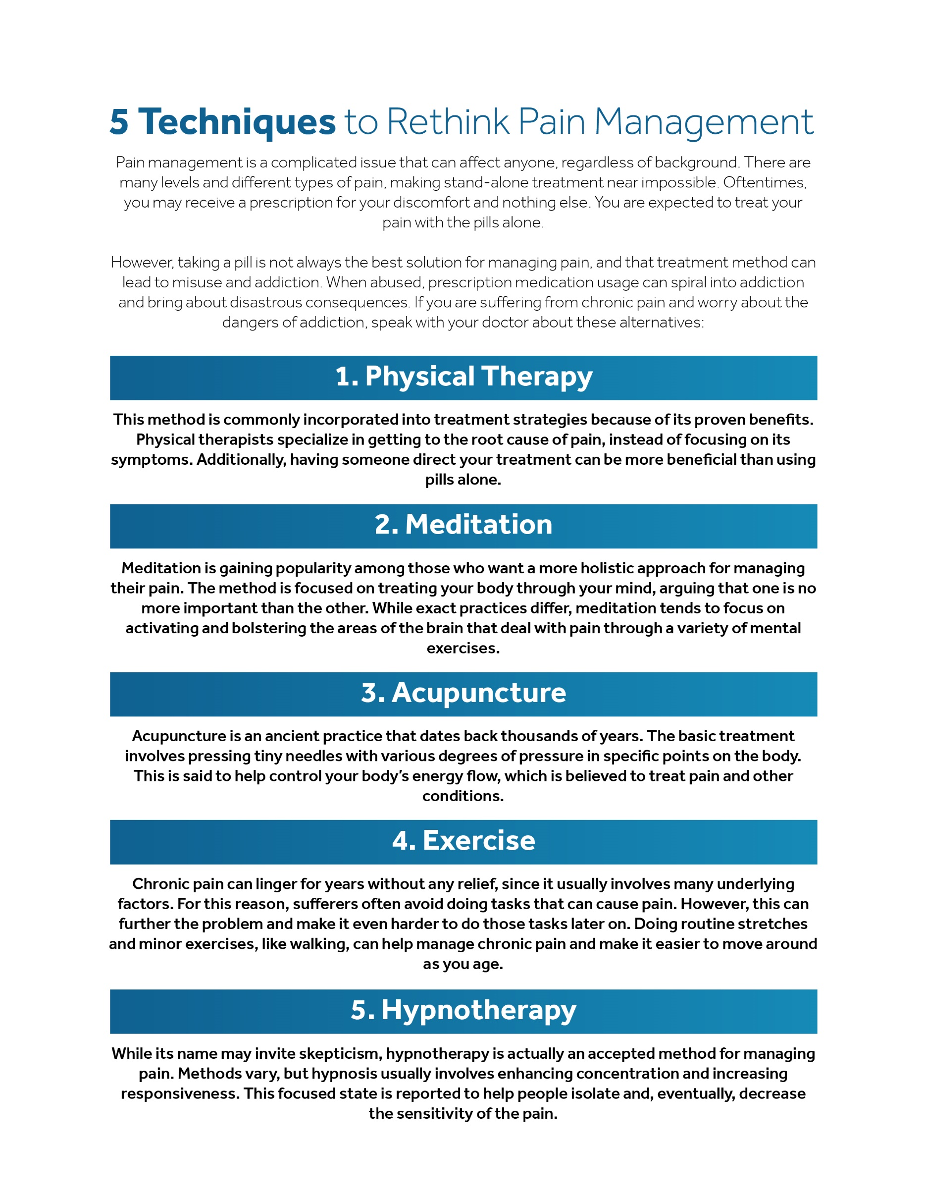
5 Techniques to Rethink Pain Management

Commonly Used Terms
The following are terms that are often used to discuss the opioid crisis. This list comes directly from the CDC, but it is not exhaustive. Please visit its website for more information on these terms and their definitions.
Acute pain – Pain that usually starts suddenly and has a known cause, like an injury or surgery. It normally gets better as your body heals and lasts less than three months.
Benzodiazepines – Sometimes called “benzos,” these are sedatives often used to treat anxiety, insomnia and other conditions. Combining benzodiazepines with opioids increases a person’s risk of overdose and death.
Chronic pain – Pain that lasts three months or more and can be caused by a disease or condition, injury, medical treatment, inflammation or even an unknown reason.
Drug misuse – The use of prescription drugs without a prescription or in a manner other than as directed by a doctor, including use in greater amounts, more often or longer than told to take a drug, or use in any other way not directed by a doctor.
Drug abuse or addiction – Dependence on a legal or illegal drug or medication. See opioid use disorder.
Extended-release/long-acting opioids – Slower-acting medication with a longer duration of pain-relieving action.
Fentanyl – Pharmaceutical fentanyl is a synthetic opioid pain medication, approved for treating severe pain, typically advanced cancer pain. It is 50 to 100 times more potent than morphine. However, illegally made fentanyl is sold through illegal drug markets for its heroin-like effect, and it is often mixed with heroin and/or cocaine as a combination product.
Heroin – An illegal, highly addictive opioid drug processed from morphine.
Illicit drugs – The nonmedical use of a variety of drugs that are prohibited by law. These drugs can include amphetamine-type stimulants, marijuana/cannabis, cocaine, heroin and other opioids, synthetic drugs and ecstasy.
Immediate-release opioids – Faster-acting medication with a shorter duration of pain-relieving action.
Medication-assisted treatment – Treatment for opioid use disorder combining the use of medications (methadone, buprenorphine or naltrexone) with counseling and behavioral therapies.
Morphine milligram equivalents – The amount of milligrams of morphine an opioid dose is equal to when prescribed. This is how to calculate the total amount of opioids, accounting for differences in opioid drug type and strength.
Naloxone – A prescription drug that can reverse the effects of an opioid overdose and can be lifesaving if administered in time. The drug is sold under the brand name Narcan or Evzio.
Nonmedical use – Taking drugs, whether obtained by prescription or otherwise, not in the way, for the reasons or during the time period prescribed. Or the use of prescription drugs by a person for whom the drug was not prescribed.
Non-opioid therapy – Methods of managing chronic pain that does not involve opioids. These methods can include, but are not limited to, acetaminophen (Tylenol) or ibuprofen (Advil), cognitive behavioral therapy, physical therapy and exercise, medications for depression or for seizures, or interventional therapies (injections).
Non-pharmacologic therapy – Treatments that do not involve medications, including physical treatments (e.g., exercise therapy or weight loss) and behavioral treatments (e.g., cognitive behavioral therapy).
Opioid – Natural or synthetic chemicals that interact with opioid receptors on nerve cells in the body and brain, and reduce the intensity of pain signals and feelings of pain. This class of drugs includes the illegal drug heroin, synthetic opioids such as fentanyl, and pain medications available legally by prescription, such as oxycodone, hydrocodone, codeine, morphine and many others. Opioid pain medications are generally safe when taken for a short time and as prescribed by a doctor, but because they produce euphoria in addition to pain relief, they can be misused.
Opioid analgesics – Commonly referred to as prescription opioids, medications that have been used to treat moderate to severe pain in some patients. Categories of opioids for mortality data include the following:
- Natural opioid analgesics, including morphine and codeine
- Semi-synthetic opioid analgesics, including drugs such as oxycodone, hydrocodone, hydromorphone and oxymorphone
- Methadone, a synthetic opioid
- Synthetic opioid analgesics other than methadone, including drugs such as tramadol and fentanyl
Opioid use disorder – A problematic pattern of opioid use that causes significant impairment or distress. A diagnosis is based on specific criteria such as unsuccessful efforts to cut down or control use, or use resulting in social problems and a failure to fulfill obligations at work, school or home. Opioid use disorder has also been referred to as “opioid abuse or dependence” or “opioid addiction.”
Overdose – Injury to the body (poisoning) that happens when a drug is taken in excessive amounts. An overdose can be fatal or nonfatal.
Physical dependence – Adaptation to a drug that produces symptoms of withdrawal when the drug is stopped.
Prescription drug monitoring programs (PDMPs) – State-run electronic databases that track controlled substance prescriptions. PDMPs help providers identify patients at risk of opioid misuse, abuse and overdose due to overlapping prescriptions, high dosages or co-prescribing of opioids with benzodiazepines.
Tolerance – Reduced response to a drug with repeated use.
 | [Insert name of Vendor 1] |  | [Insert name of Vendor 2]
 | Yes or Present | No or Absent | Yes or Present | No or Absent
Necessary Components
Accredited laboratories where samples are tested
Reputation for quality
Customer support for questions about results
Follow-up tests to confirm positive test results
Ability to determine if a sample has been tampered with
Offers customizable testing (especially important when checking for opioids)
Flexible collection methods (on-site or not)
Medical review officers on staff
Quick analysis and turnaround time
Fair prices
[Insert additional component]
[Insert additional component]
[Insert additional component]
[Insert additional component]
[Insert additional component]
[Insert additional component]

Drug Testing Company Vendor Comparison Worksheet

Opioid Alternatives for Pain Management
A number of medications and treatments exist that can help manage pain, with fewer risks and side effects. Some were mentioned earlier in this toolkit. Consider emailing this list or sharing it on social media to educate employees about pain management alternatives.
Talk with your doctor about the benefits of using one of the below methods if you suffer from chronic pain. Some of the options may even work more effectively than opioids, depending on the type of pain. Here are some of the alternative solutions proposed by the CDC:
- Acetaminophen (Tylenol) or ibuprofen (Advil)
- Cognitive behavioral therapy—a psychological, goal-directed approach in which patients learn how to modify physical, behavioral, and emotional triggers of pain and stress
- Exercise therapy, including physical therapy
- Medications for depression or for seizures
- Interventional therapies (injections)
- Exercise and weight loss
- Other therapies such as acupuncture and massage

Substance Abuse Incident Report Form
Employee Name: ________________________________________ Date of Incident: ____________
Employee Department: __________________________________________________________________

Substance Offense:
- Confirmed use | - Possession | - Distribution (sale) | - Suspicion

Suspected Illicit Substance (check all that apply):
- Alcohol | - Marijuana | - Cocaine
- Narcotics (heroin, fentanyl, etc.) | - Opioids (painkillers) | - Other (specify if possible)  _____________________________

Explanation of Incident or Suspicion: ________________________________________________________________________________________________________________________________________________________________________________________________________________________________________________________________________________________________________________________________________________________________________________________________________________________________________________________________________________________________________________________________________________________________________________________________________________________________________________________________________________________________________

By signing, I acknowledge that the information contained on this form is truthful to the best of my knowledge. I understand that I am subject to follow-up questions regarding this report and agree to respond truthfully.
_______________________________________________ ________________________________
Reporter Name (print) Contact Information
_______________________________________________ _______________________
Reporter Signature Date

Consent to Drug and Alcohol Testing Form
I, [insert your name], have received, read, understand and agree to the Drug and Alcohol Testing Policy in its entirety. If I had questions regarding the policy, I have asked and received explanations, clearing up any confusion I may have had. I have also been advised that any future questions can be directed to Human Resources.
I hereby authorize YOUR COMPANY NAME to conduct any and all drug testing required and under the terms of the Drug and Alcohol Testing Policy. In conjunction with this, I hereby authorize physicians, nurses and technicians from medical and health care facilities or collections of laboratories to collect urine, blood, breath and/or saliva specimens for the purpose of determining the presence, content and/or quantity of a controlled substance or alcohol in my body.
I understand and agree that my test results will be disclosed to YOUR COMPANY NAME. I hereby release the medical or health care facility, collection laboratory and any of its employees or agents involved in my test(s) and YOUR COMPANY NAME from any and all claims which may result from the disclosure of my test results.
I also understand that the Drug and Alcohol Testing Policy is subject to change without notice in order to maintain compliance with government standards, industry standards and Company policies.

___________________________________________
Employee Signature
___________________________________________
Employee Printed Name

___________________________________________
Employee Social Security Number

___________________________________________
Date Received by Human Resources

EAP Announcement Email for Employees
Dear YOUR COMPANY NAME employee,
We are committed to the health and well-being of our staff. It is in this spirit that we are announcing a new employee assistance program (EAP) for you to take advantage of, free of charge. If you are struggling with a personal matter, our EAP can help you tackle the issue before it becomes more serious and difficult to manage.
What is an EAP?
An EAP is an employer-sponsored program that offers services to help you deal with personal problems confidentially. EAPs can help reduce your health care and disability claims, increase your productivity and morale, and help you feel more confident about handling your personal and professional responsibilities. High stress, psychological problems, substance abuse and legal troubles are all examples of areas where an EAP can help.
For more information about covered services or questions on getting started, please contact the Human Resources department.
Best regards,
[Insert name]
[Insert title]

Sample Social Media Communications for Employee Education
Employers must provide employees with useful education materials if they want to lower their workforces’ risk of opioid abuse. This section offers sample social media posts that you can use to engage with employees and educate them on the topic of opioids. The information here is not only for social media platforms and can be used anywhere you typically engage with employees, like email or an intranet site.
Additionally, the CDC features optimized content for you to share on your social media platforms. Here are a few postings from their Rx awareness campaign. Visit its website for sharable images and more postings to maximize your resources. Please note some postings may require customization.

CDC Campaign Postings
- Prescription #opioids have serious risks of abuse and overdose. Learn what YOUR COMPANY NAME is doing to help reduce these risks in our communities. [insert website URL] #RxAwareness
- #RxAwareness starts with you. Tell others how prescription #opioids have affected you. Learn more at cdc.gov/RxAwareness.
- Devin’s addiction to prescription #opioids began with a minor surgery at age 16. Learn more about the dangers of prescription opioids at cdc.gov/RxAwareness. #RxAwareness
- Real stories. Real people. Noah lost his dad from prescription #opioid overdose. Hear more at cdc.gov/RxAwareness. #RxAwareness
- It only takes a little to lose a lot. What’s your prescription #opioid story? #RxAwareness cdc.gov/RxAwareness
- #RxAwareness starts with you. Tell others how prescription #opioids have affected you at cdc.gov/RxAwareness.
- Prescription #opioids can be addictive and dangerous. Learn more at cdc.gov/RxAwareness. #RxAwareness
- Know the risks associated with prescription #opioids. Talk to your doctor about #RxAwareness. cdc.gov/RxAwareness
- Prescription #opioids can help manage pain but have a serious risk of abuse & overdose. cdc.gov/RxAwareness #RxAwareness [insert website URL]

Additional Sample Posts
- Prescription painkillers can be addictive and dangerous. Learn more about alternative solutions to manage your pain. #RxAwareness
- Secrets keep you sick. Talk with your doctor if you’re feeling overwhelmed by your prescription painkillers. #RxAwareness
- Don’t be fooled by your painkillers. Just because they are prescribed does not make them risk-free. Learn more about the dangerous consequences of abusing opioids. #RxAwareness
- Over 42,000 people die from opioid overdoses each year. If you or a loved one are suffering from addictive painkillers, talk with YOUR COMPANY NAME about getting back in control. We have the resources to help. #RxAwareness
- Is your prescription lasting longer than your pain? Talk with your doctor about reducing your painkillers to lower your risk of addiction. #RxAwareness
- Addiction can be prevented. Talk to your doctor about the risks of prescription painkillers. #RxAwareness
- 1 in 4 patients who receive long-term prescription painkiller treatment struggle with addiction. Don’t keep quiet about addiction—you are not alone. YOUR COMPANY NAME can help. #RxAwareness
- Chances are you know someone struggling with prescription painkiller addiction. Don’t suffer in silence. Talk with YOUR COMPANY NAME about getting help for you or a loved one. #RxAwareness
- Addiction has many faces. Click here to learn more about the real people suffering from prescription painkillers. #RxAwareness

Reasonable Suspicion Checklist
Follow this checklist if you suspect an employee of substance abuse or creating an unsafe environment by using prescription opioids. Please note this checklist is intended as a sample procedure and should not be construed as legal advice.
- Consult your drug policy and follow all the appropriate steps before speaking with the employee.
- Speak with other stakeholders within your organization about the situation. These people can include other supervisors, HR representatives and EAP professionals.
- Confidentially approach the employee in a safe environment with appropriate stakeholders present—likely the EAP professionals. Managers are not there to diagnose substance abuse. They are merely opening a dialogue and offering evidence for their concerns.
- Allow the EAP professionals to diagnosis and make any treatment referrals. If they determine the substance abuse accusations against an employee have merit, EAP professionals will recommend suitable treatment options.
- Monitor the employee and continue to track his or her performance. Stakeholders may recommend mandatory treatment if the substance abuse is interfering with the workplace. In this case, proof of the employee’s treatment participation should be required.
- Follow up with the employee periodically (and confidentially) to see if he or she needs additional help or resources to stay on course with treatment. Depending on the situation, the employee may need to be referred to your organization’s EAP.

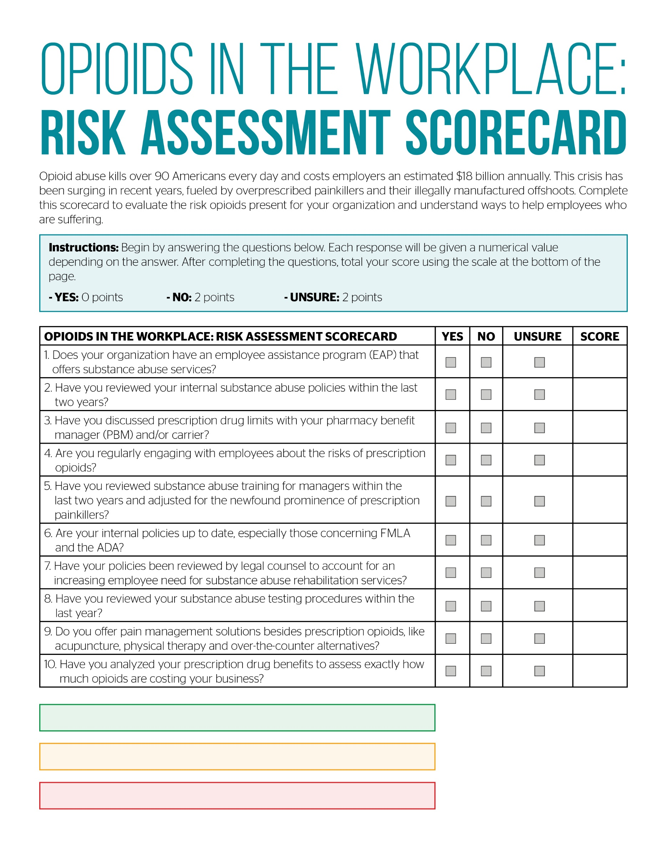
Opioids in the Workplace: Risk Assessment Scorecard
Low risk. Contact Wells Insurance to confirm: 0-6

Moderate risk. Contact Wells Insurance today: 7-14

High risk. Contact Wells Insurance today: 15-20

Sample Last Chance Agreement
Typically, employees are terminated immediately for seriously violating company policies and rules, and for behavior deemed inappropriate by company standards. However, YOUR COMPANY NAME is offering [insert employee name] a final opportunity to retain employment based on [insert circumstances for this opportunity].
In lieu of outright termination, both YOUR COMPANY NAME and [insert employee name] agree to the following conditions:
[Insert employee name] will be suspended without pay for [insert number] days. Additionally, the employee will be required to complete an improvement plan within [insert timetable] and review company expectations.
The employee acknowledges this is a final opportunity to continue employment and that failure to show improvement, or a repeat of the aforementioned violation, within [insert timetable] will trigger an immediate termination.
YOUR COMPANY NAME is an at-will employer and [insert name] understands this agreement does not protect against additional disciplinary action, including termination, for policy violations.

_______________________________________________  Employee Signature  _______________________________________________  Employee Printed Name | __________________  Date
_______________________________________________  Immediate Supervisor Signature  _______________________________________________  Immediate Supervisor Printed Name | __________________  Date
_______________________________________________  Human Resources Director Signature  _______________________________________________  Human Resources Director Printed Name | __________________  Date

Sample Federal Family and Medical Leave Policy
As an employee of YOUR COMPANY NAME, you may be eligible to take unpaid family and medical leave under the federal Family and Medical Leave Act (FMLA). This policy provides an introduction to the rights and provisions of the federal FMLA. An FMLA summary that is based on the Department of Labor’s model notice is attached to this policy and further explains the FMLA. If you have questions regarding the FMLA, please contact Human Resources.
Eligibility
To be eligible for leave, you must have been employed by the Company for at least 12 months. In the 12 months immediately preceding the beginning of the leave, you must also have worked at least 1,250 hours to qualify for federal FMLA. In addition, you must work in an office or worksite where 50 or more employees are employed within 75 miles of that office or worksite.
Amount of Leave Available
Eligible employees may take up to a total of 12 weeks of FMLA leave within a rolling 12-month period, measured backward from the date an employee uses any FMLA leave, for any combination of the following reasons:
- The birth of an employee’s newborn child or the placement of a child with the employee for adoption or foster care
- To care for the employee’s spouse, child or parent with a serious health condition
- The employee has a serious health condition that makes him or her unable to perform the functions of his or her job
- A qualifying exigency that arises because the employee’s spouse, child or parent is a covered military member on covered active duty (or has been notified of an impending call or order to covered active duty)
When leave is taken to care for a covered service member with a serious injury or illness, a spouse, child, parent or next of kin may take up to 26 weeks of unpaid FMLA leave during a single 12-month period. Eligible employees are limited to a total of 26 workweeks of FMLA-protected leave during that 12-month period. For example, an employee cannot take 26 workweeks of FMLA leave to care for a covered service member and then take 12 more weeks for other FMLA qualifying reasons.
Under the federal FMLA, spouses employed by the Company are jointly entitled to a combined total of 12 weeks of leave for the birth of a newborn child, for the placement of a child for adoption or foster care, and to care for a parent who has a serious health condition. The federal FMLA does not cover care for parents-in-law. Spouses employed by the Company are jointly entitled to a combined total of 26 weeks of leave to care for a covered service member.
Types of Leave Available
Birth or placement for adoption or foster care: FMLA leave is available to eligible male and female employees for the birth of a child or for the placement of a child with the employee for purposes of adoption or foster care. FMLA leave must be completed within 12 months of the birth or placement. This type of leave may not be taken intermittently or on a reduced schedule unless the Company agrees to this request. See below for more details on noncontinuous leave.
Serious health condition of employee: If, as an eligible employee, you experience a serious health condition as defined by the FMLA, you may take medical leave under this policy (see “Definitions” for the definition of serious health condition). A serious health condition generally occurs under the following circumstances:
- You receive inpatient care in a hospital, hospice or nursing home.
- You suffer a period of incapacity accompanied by continuing outpatient treatment or care by a health care provider.
- You have a history of a chronic condition that may cause episodes of incapacity
The following provisions apply to leave for the serious health condition of an employee:
- Noncontinuous leave—Medical leave may be taken all at once or, when medically necessary, intermittently or on a reduced leave schedule (see below).
- Certification process—The need for leave must be documented by your treating health care provider through our medical certification process (see below).
- Fitness-for-duty statement—A fitness-for-duty statement will be required in order for you to return from a medical leave. Failure to provide the statement will result in a delay in your return to work.
Serious health condition of immediate family member: If, as an eligible employee, you need family leave in order to care for your child, spouse or parent who experiences a serious health condition as defined by the FMLA (see “Definitions” for definitions of child, spouse, parent and serious health condition), you may take a leave under this policy.
- Noncontinuous leave—Leave may be taken all at once or, when medically necessary, intermittently or on a reduced leave schedule (see below).
- Certification process—The need for leave must be documented by the family member’s treating health care provider through our medical certification process (see below).
Qualifying exigency because of active duty: If, as an eligible employee, you need family leave because of any qualifying exigency arising out of the fact that your spouse, son, daughter or parent is on covered active duty in the armed forces (including the National Guard or Reserves), or has been notified that they will be called or ordered to covered active duty in the armed forces (including the National Guard or Reserves), you may take family leave under this policy. (See “Definitions” for a definition of qualifying exigency)
- Noncontinuous leave—Family leave for any qualifying exigency arising out of the covered active duty of a family member may be taken all at once, intermittently or on a reduced leave schedule (see below).
- Certification process—The need for leave must be documented through our certification process (see below).
Service member family leave: If, as an eligible employee, you need family leave to care for a covered service member who is your spouse, child, parent or next of kin and who is undergoing medical treatment, recuperation or therapy, is otherwise in outpatient status or is otherwise on the temporary disability retired list for a serious injury or illness, you may take up to 26 weeks of unpaid leave during a single 12-month period under this policy. (See “Definitions” for a definition of covered service member and serious injury or illness)
Effective March 8, 2013, an eligible employee may take service member family leave to care for a covered veteran who is the employee’s spouse, child, parent or next of kin and who is undergoing medical treatment, recuperation or therapy for a serious injury or illness. (See “Definitions” for a definition of covered veteran)
- Noncontinuous leave—Service member family leave may be taken all at once or, when medically necessary, intermittently or on a reduced leave schedule (see below).
- Certification process—The need for leave must be documented by the family member’s treating health care provider through our medical certification process (see below).
Notifying the Company of the Need for Family or Medical Leave
Generally, an application for leave must be completed for all leave taken under this policy. A nonemergency leave should generally be requested from Human Resources at least 30 days, or as soon as practical, in advance of the date the leave is expected to begin. In cases of emergency, you (or your representative, if you are incapacitated) should give verbal notice as soon as possible, and the application form should be completed as soon as practical. Failure to provide adequate notice may, in the case of foreseeable leave, result in a delay or denial of leave. It is your responsibility to notify your manager and Human Resources of absences that may be covered by the FMLA.
You must provide sufficient information regarding the reason for an absence for the Company to know that protection may exist under this policy. Failure to provide this information will result in delay or forfeiture of rights under this policy. This means the absence may then be counted against your record for purposes of discipline for attendance or similar matters.
Medical Certification Process
In addition to an application for leave, you will be required to complete a medical certification form when leave is for a family member’s or your own serious health condition. The certification form needs to be signed by the health care provider. The short-term disability certification may be sufficient where the information required is duplicative. These forms are available from Human Resources. Second or third certifications from health care providers and periodic recertification at the Company’s or your expense may be required under certain circumstances.
We may also require periodic reports during federal FMLA leave regarding your status and intent to return to work.

Military Family Leave Certifications
In addition to an application for leave, you will be required to complete a Certification of Qualifying Exigency for Military Family Leave form when leave is for a qualifying exigency. A copy of the military member’s active duty orders or other military documentation may also be required to substantiate your need for FMLA leave.
If you request leave to care for a covered service member with a serious injury or illness, you will be required to complete a medical certification form, which must be signed by the service member’s health care provider. The certification form will request additional information, such as information regarding the relationship between you and the covered service member, to substantiate your need for FMLA leave.
Substituting Paid Leave for Unpaid Leave
Federal FMLA leave is unpaid. The Company requires you to substitute vacation days according to the schedule below. You may also choose to substitute additional paid or unpaid leave that you have accrued.
When you substitute vacation days or other paid leave, the absence will be counted against your entitlement to FMLA leave under this policy and will not extend your leave. In other words, you are using your paid leave concurrently with your FMLA leave.
Eligible Vacation Remaining | Required Substitution
Less than 5 days | None
5-8 days | 3 days
9-12 days | 5 days
13-16 days | 7 days
17-20 days | 9 days

When an employee is absent due to a work-related illness or injury that meets the definition of a serious health condition, the absence will be counted against the employee’s entitlement under this policy. In other words, the employee is using FMLA leave concurrently with the workers’ compensation absence. An employee is not required to substitute paid time off for an absence covered under workers’ compensation.
You may be paid for all or part of a medical leave to the extent you are eligible for benefits such as short-term disability. An employee is not required to substitute paid time off for an absence covered under a disability benefit plan.
Noncontinuous Leave
Intermittent or reduced leave will be permitted only when it is medically necessary or for a qualifying exigency, as explained above. In all cases, the total amount of leave taken in a calendar year should not exceed your total allotment as defined earlier in this policy.
Intermittent and reduced schedule leave must be scheduled with minimal disruption to an employee’s job. To the extent possible, medical appointments and treatments related to an employee’s or family member’s serious health condition should be scheduled outside of working hours or at such times that allow for a minimal amount of time away from work.
If you request noncontinuous federal FMLA leave which is foreseeable based on planned medical treatment for yourself, a family member or a covered service member, you may be required to transfer temporarily to an available alternative position offered by the Company for which you are qualified and which better accommodates recurring periods of leave than your regular employment position. You will be entitled to equivalent pay and benefits, but will not necessarily be assigned the same duties in the alternative position. This provision may also apply if the Company approves a noncontinuous leave for the birth of a child or the placement of a child for adoption or foster care.
Benefit Continuation During Leave
The Company will maintain your group health plan coverage and certain other employment benefits (such as group life insurance, AD&D insurance, and health and dependent flexible spending accounts) during your FMLA leave on the same terms as if you had continued to work, if these benefits were provided to you before the leave was taken. You will be required to pay your regular portion of premiums. Contact Human Resources for an explanation of your options.
Benefits that are accumulated based upon hours worked will not accumulate during the period of FMLA leave.
In some instances, the Company may recover premiums it paid to maintain health plan coverage for an employee who fails to return to work from FMLA leave.
Returning to Work
If the reason for FMLA leave is for your own serious health condition, you will be required to present a fitness-for-duty certification immediately upon return to work.
If you wish to return to work before the scheduled expiration of FMLA leave, you must notify the Company of the change in circumstances as soon as possible, but no later than two working days prior to your desired return date.
If you exhaust all leave under this policy and are still unable to return to work, you must notify the Company as soon as possible. Your situation will be reviewed to determine what rights and protections might exist under other Company policies.
Rights upon Return from Leave
Upon return from family or medical leave, you will be returned to the position you held immediately prior to the leave, if the position is vacant. Certain exceptions exist for key employees, as defined by law. If the position is not vacant, you will be placed in an equivalent employment position with equivalent pay, benefits, and other terms and conditions of employment.
The law provides that an employee on leave has no greater rights than the employee would have had if the employee had continued to work. Therefore, you may be affected by a layoff, termination or other job change if the action would have occurred had you remained actively at work.
Other Types of Leave
If you do not qualify for the types of leave described in this policy, the Company may approve a personal leave of absence, depending on your circumstances. Except where mandated by law, we cannot guarantee that benefits will continue or that your position will remain open in your absence.
Definitions
- Spouse—A husband or wife as defined or recognized under state law for purposes of marriage in the state in which the marriage was entered into. This definition also includes an individual in a same-sex or common law marriage that was entered into in a state that recognizes these marriages. An opposite-sex, same-sex or common law marriage that was entered into outside of any state will be recognized if the marriage is valid in the place where it was entered into and the marriage could have been entered into in at least one state.
- Parent—A biological parent, adoptive parent, stepparent, foster parent, or an individual who provides or provided day-to-day care or financial support to the child. Parent does not include a parent-in-law under this law.
- Child—A biological, adopted or foster child, stepchild, legal ward, or a child who is receiving day-to-day care or financial support from the employee and is under the age of 18. Child also includes a person 18 years of age or older who is incapable of self-care because of a mental or physical disability. For military family leave, the child does not have to be a minor (under the age of 18) and can be of any age.
  - Incapable of self-care—The child requires active assistance or supervision to provide daily self-care in three or more “activities of daily living,” or “instrumental activities of daily living,” including adaptive activities such as caring appropriately for one’s grooming and hygiene, bathing, dressing, eating or instrumental activities such as shopping, taking public transportation or maintaining a residence.
  - Physical or mental disability—A physical or mental impairment that substantially limits one or more major life activity of the individual.
- Covered service member—A member of the armed forces, including a member of the National Guard or Reserves, who is undergoing medical treatment, recuperation or therapy, is otherwise in outpatient status or is otherwise on the temporary disability retired list for a serious injury or illness.
- Covered veteran—An individual who is undergoing medical treatment, recuperation, or therapy for a serious injury or illness and who was a member of the armed forces (including a member of the National Guard or Reserves), and was discharged or released under conditions other than dishonorable at any time during the five-year period prior to the first date the eligible employee takes FMLA leave to care for the covered veteran.
- Next of kin—Used with respect to an individual, this means the nearest blood relative of that individual, other than the spouse, parent or child.
- Serious health condition—Illness, injury, impairment, or physical or mental condition that involves any of the following circumstances:
  - Inpatient care in a hospital, hospice or residential medical care facility.
  - A period of incapacity of more than three consecutive calendar days (including any subsequent treatment or period of incapacity relating to the same condition) that also involves: 1) treatment two or more times within 30 days of the first day of incapacity, unless extenuating circumstances exist, by or under the orders of a health care provider; or 2) treatment by a health care provider on at least one occasion which results in a regimen of continuing treatment under the supervision of a health care provider. The first (or only) visit must occur in person within seven days of the first day of incapacity.
  - Any incapacity due to pregnancy or for prenatal care.
  - Chronic conditions requiring periodic treatment by or under the supervision of a health care provider, which continue over an extended period of time and may cause an episodic rather than a continuing period of incapacity (for example, asthma, diabetes and epilepsy).
  - Permanent or long-term conditions requiring supervision for which treatment may not be effective (for example, Alzheimer’s, a severe stroke or the terminal stages of a disease).
  - Multiple treatments by or under the supervision of a health care provider either for restorative surgery after an accident or other injury, or for a condition that would likely result in a period of incapacity of more than three calendar days in the absence of medical intervention or treatment, such as cancer (chemotherapy), severe arthritis (physical therapy) or kidney disease (dialysis).
- Serious injury or illness—Can be any of the following circumstances:
  - In the case of a member of the armed forces, including a member of the National Guard or Reserves, an injury or illness incurred by the member in the line of duty on active duty in the armed forces (or existed before the beginning of the member’s active duty and was aggravated by service in the line of duty on active duty in the armed forces) and that may render the member medically unfit to perform the duties of the member’s office, grade, rank or rating.
  - In the case of a veteran who was a member of the armed forces, including a member of the National Guard or Reserves, an injury or illness incurred by the member in the line of duty on active duty in the armed forces (or existed before the beginning of the member’s active duty and was aggravated by service in the line of duty on active duty in the armed forces) and that manifested itself before or after the member became a veteran and is any of the following:
    - A continuation of a serious injury or illness that was incurred or aggravated when the covered veteran was a member of the armed forces and rendered the service member unable to perform the duties of the service member’s office, grade, rank or rating.
    - A physical or mental condition for which the covered veteran has received a U.S. Department of Veterans Affairs Service-related Disability Rating (VASRD) of 50 percent or greater, and such VASRD rating is based, in whole or in part, on the condition precipitating the need for service member family leave.
    - A physical or mental condition that substantially impairs the covered veteran’s ability to secure or follow a substantially gainful occupation by reason of a disability or disabilities related to military service, or would do so absent treatment.
    - An injury, including a psychological injury, on the basis of which the covered veteran has been enrolled in the Department of Veterans Affairs Program of Comprehensive Assistance for Family Caregivers.
- Qualifying exigency—Includes the following:
  - Short-notice deployment (seven days or less)
  - Military events and related activities
  - Child care and school activities
  - Financial and legal arrangements
  - Counseling
  - Rest and recuperation (up to 15 days)
  - Post-deployment activities
  - Parental care
  - Additional activities agreed to by the Company and the employee
More Information
Please contact Human Resources for additional information.

Employee Rights and Responsibilities under FMLA

Basic Leave Entitlement
FMLA requires covered employers to provide up to 12 weeks of unpaid, job-protected leave to eligible employees for any of the following reasons:
- Incapacity due to pregnancy, prenatal medical care or child birth
- To care for the employee’s child after birth, or placement for adoption or foster care
- To care for the employee’s spouse, son, daughter or parent, who has a serious health condition
- A serious health condition that makes the employee unable to perform the employee’s job
Military Family Leave Entitlements
Eligible employees whose spouse, son, daughter or parent is on covered active duty or call to covered active duty status may use their 12-week leave entitlement to address certain qualifying exigencies. Qualifying exigencies may include attending certain military events, arranging for alternative child care, addressing certain financial and legal arrangements, attending certain counseling sessions and attending post-deployment reintegration briefings.
FMLA also includes a special leave entitlement that permits eligible employees to take up to 26 weeks of leave to care for a covered service member during a single 12-month period. A covered service member is: (1) a current member of the armed forces, including a member of the National Guard or Reserves, who is undergoing medical treatment, recuperation or therapy, is otherwise in outpatient status, or is otherwise on the temporary disability retired list, for a serious injury or illness*; or (2) a veteran who was discharged or released under conditions other than dishonorable at any time during the five-year period prior to the first date the eligible employee takes FMLA leave to care for the covered veteran, and who is undergoing medical treatment, recuperation, or therapy for a serious injury or illness.*
*The FMLA definitions of “serious injury or illness” for current service members and veterans are distinct from the FMLA definition of “serious health condition.”
Benefits and Protections
During FMLA leave, the employer must maintain the employee’s health coverage under any group health plan on the same terms as if the employee had continued to work. Upon return from FMLA leave, most employees must be restored to their original or equivalent positions with equivalent pay, benefits and other employment terms.
Use of FMLA leave cannot result in the loss of any employment benefit that accrued prior to the start of an employee’s leave.
Eligibility Requirements
Employees are eligible if they have worked for a covered employer for at least 12 months, have 1,250 hours of service in the previous 12 months* and if at least 50 employees are employed by the employer within 75 miles.
*Special hours of service eligibility requirements apply to airline flight crew employees.
Definition of Serious Health Condition
A serious health condition is an illness, injury, impairment, or physical or mental condition that involves either an overnight stay in a medical care facility, or continuing treatment by a health care provider for a condition that either prevents the employee from performing the functions of the employee’s job, or prevents the qualified family member from participating in school or other daily activities.
Subject to certain conditions, the continuing treatment requirement may be met by a period of incapacity of more than three consecutive calendar days combined with at least two visits to a health care provider or one visit and a regimen of continuing treatment, or incapacity due to pregnancy, or incapacity due to a chronic condition. Other conditions may meet the definition of continuing treatment.
Use of Leave
An employee does not need to use this leave entitlement in one block. Leave can be taken intermittently or on a reduced leave schedule when medically necessary. Employees must make reasonable efforts to schedule leave for planned medical treatment so as not to unduly disrupt the employer’s operations. Leave due to qualifying exigencies may also be taken on an intermittent basis.
Substitution of Paid Leave for Unpaid Leave
Employees may choose or employers may require use of accrued paid leave while taking FMLA leave. In order to use paid leave for FMLA leave, employees must comply with the employer’s normal paid leave policies.
Employee Responsibilities
Employees must provide 30 days advance notice of the need to take FMLA leave when the need is foreseeable. When 30 days notice is not possible, the employee must provide notice as soon as practicable and generally must comply with an employer’s normal call-in procedures.
Employees must provide sufficient information for the employer to determine if the leave may qualify for FMLA protection and the anticipated timing and duration of the leave. Sufficient information may include that the employee is unable to perform job functions, the family member is unable to perform daily activities, the need for hospitalization or continuing treatment by a health care provider, or circumstances supporting the need for military family leave. Employees also must inform the employer if the requested leave is for a reason for which FMLA leave was previously taken or certified. Employees also may be required to provide a certification and periodic recertification supporting the need for leave.
Employer Responsibilities
Covered employers must inform employees requesting leave whether they are eligible under FMLA. If they are, the notice must specify any additional information required as well as the employees’ rights and responsibilities. If they are not eligible, the employer must provide a reason for the ineligibility.
Covered employers must inform employees if leave will be designated as FMLA-protected and the amount of leave counted against the employee’s leave entitlement. If the employer determines that the leave is not FMLA-protected, the employer must notify the employee.
Unlawful Acts by Employers
FMLA makes it unlawful for any employer to do the following:
- Interfere with, restrain or deny the exercise of any right provided under FMLA.
- Discharge or discriminate against any person for opposing any practice made unlawful by FMLA or for involvement in any proceeding under or relating to FMLA.
Enforcement
An employee may file a complaint with the U.S. Department of Labor or may bring a private lawsuit against an employer.
FMLA does not affect any federal or state law prohibiting discrimination, or supersede any state or local law or collective bargaining agreement which provides greater family or medical leave rights.

FMLA Section 109 (29 U.S.C. § 2619) requires FMLA covered employers to post the text of this notice. Regulation 29 C.F.R. § 825.300(a) may require additional disclosures.

